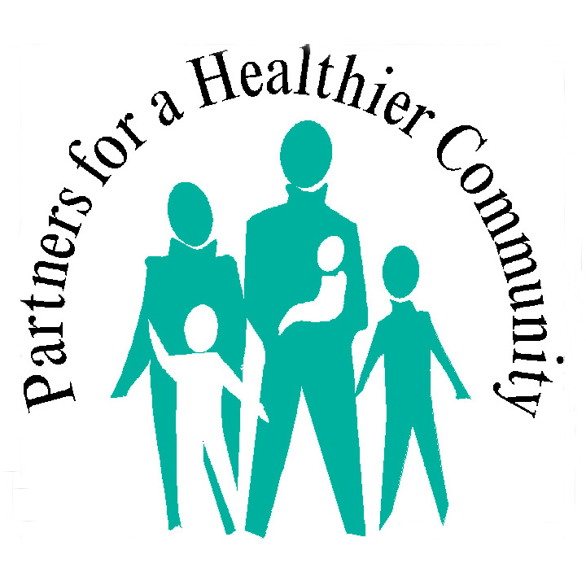
2014-2019 Action Plan Workbook
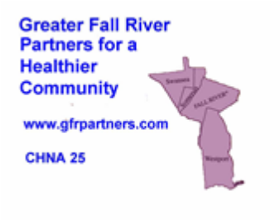

A Community Health Network area (CHNA) is a local coalition of public, non-profit, and private sector groups that work together to build healthier communities in Massachusetts through community-based prevention planning and health promotion. The geographic definition of the South Coast region for this report is defined as Community Health Network Areas 25. To enhance readability of this report, CHNA 25 will be referred to as “Greater Fall River,” which is the population area for Partners for a Healthier Community Communities: Fall River, Somerset, Swansea, and Westport. Since many statistics also include the City of Fall River and the surrounding area, the term “South Coast” will refer to the 15-town area that surrounds these two cities. The report is assembled to provide a detailed description of the 2014-2019 Community Health Action Plan for Partners for a Healthier Community and a vehicle for reporting progress on each of the identified objectives.
Introduction and Invitation to Participate
Every five years, Greater Fall River Partners for a Healthier Community, Inc. (Partners) conducts a community-wide health needs assessment upon which an Action Plan for the following five-year period is built. The process occurred first in 2004 with the creation of the Healthy City Fall River initiative that used a citywide survey to create the first five-year Action Plan for the City. It was enlarged again in 2009 with the addition of the Mass In Motion initiative that shifted to a focus on system, policy and environmental changes to support healthier lifestyles.
Through this process, much has been gained. Our smoking rates have dropped fourteen percent. Our youth violence rate has dropped 37 percent. Teen pregnancy rates are at their lowest rate in the past twenty years. And, our high school completion rate has improved from 57 percent in 2007 to almost 80% percent in 2011, the highest rate ever. In addition, we have added three farmers’ markets, a healthy dining program in our restaurants, a healthy market program in our neighborhoods. Three of our parks have had major improvements and plans are well underway to expand a new bicycle and walking trail through the heart of the City. In February 2013, Fall River was chosen by the Robert Wood Johnson Foundation as one of six communities across the nation doing the most to improve community health.
Despite these accomplishments, the City of Fall River still has challenges. Too many people are obese and at increased risk of developing diabetes, already at the highest rate in the state. Too many people are addicted to substances, including tobacco, alcohol, heroin and prescription drugs. Our emergency rooms are filled with people who could best be served outside of the hospital, in some cases by community health workers. We lose an average of twelve people a year to overdoses. Street crime and gang violence prevents many from getting outdoors for physical activity. While educational levels are increasing, far too many young people fail to complete at least a high school education. Most of these factors are also significantly higher for persons who do not speak English at home or who are recently arrived from other countries. And, while the surrounding towns of Somerset, Swansea and Westport are less affected by these factors, problems such as binge drinking are significantly higher when compared with state averages.
It would be wonderful if we had all of the resources needed to address all of these problems. Though we have been able to capture grant funding from another of sources and mobilized the resources we have within the community to attack some of these problems, we still must prioritize our efforts and focus on problems that are especially destructive as well on approaches that we know will produce tangible results. This is the reason that we conduct a Needs and Assets Assessment and develop a planned approach every five years to improving the health of the community.
Outline of the Process
The Action Planning Process began in September 2013 with the designation of eight short-term Task Forces (see chart, below) mobilized around a subset of issues related to the health of the community. Building on the work of America's Health Rankings and the University of Wisconsin Population Health Institute, the approach was based on a model of population health that emphasizes the many factors that, if improved, can help make communities healthier places to live.
Task Force groups of between five and twenty people were convened to review the available data on both needs and assets and then asked to come up with a list of no more than ten recommendations, listed in order of priority. These lists were then presented at a series of Community Health Assessment Forums in the spring of 2014 where representatives of all eight Task Forces met to present their findings. The entire group then prioritized the top recommendations that constituted a draft Action Plan. The Action Plan was then reviewed at a public forum on June 10, 2014 for further input. A final Action Plan was prepared and approval voted on June 26, 2014.
As in past year, the five-year Action Plan will be reviewed and updated annually. Where quantitative measures of progress can be monitored, data on trends will be reported to the community. Approaches that demonstrate improvement will be continued or, if possible, amplified. Where measures show a lack of progress, new approaches will be launched and monitored. All approaches to health improvement will be based on scientifically validated methods, paying special attention to new studies that demonstrate promising results.

Health Factor Descriptions and Workbook Page Numbers
Health Determinants | # | Factors Affecting Health Status | Specific Measures | Examples of Outcomes
Health Behaviors (30%)* | I | Diet & Exercise (Pages 4-19) | Poor diet, inactivity, knowledge of and access to healthy food | Lower diabetes, heart disease, some cancers rates
 | II | Tobacco, Alcohol and Other Drug Use Prevention (Pages 20-25) | Smoking, prescription and illegal drug use | Less drug or alcohol addiction, overdose
 | III | Sexual Activity & Infectious Diseases (Pages 26-28) | STDs, HIV, teen pregnancy | Less infertility, AIDS, premature parenting
Clinical Care (20%)* | IV | Access to Quality Dental, Health, Mental Health and Substance Abuse Care (Pages 29-32) | Insurance coverage, waiting times, lack of support outside medical settings | Less delayed or inappropriate treatment, oral pain, stress, depression, suicide
Social and Environmental Factors (40%)* | V | Education, Employment, Income and Disability (Pages 33-36) | Low graduation rates, job creation, adult education | Lower unemployment, health illiteracy, economic stress
 | VI | Community Safety and Violence Prevention (Pages 37-40) | Crime, abuse, bullying | Less PTSD, premature death
 | VII | Family, Cultural and Social Support, and Housing (Pages 41-45) | Language, race, ethnicity, cultural values, maternal care, single parent households, homelessness | Decreased racism, stress, disconnection from community resources
Physical Environment (10%)* | VIII | Environment and Infrastructure (46-50) | Transportation | Increased physical activity
*Percentage of contribution to the overall health of the population (Source: Population Health Institute, County Rankings and Roadmaps, Robert Wood Johnson Foundation)
Factor I: Nutrition and Physical Activity
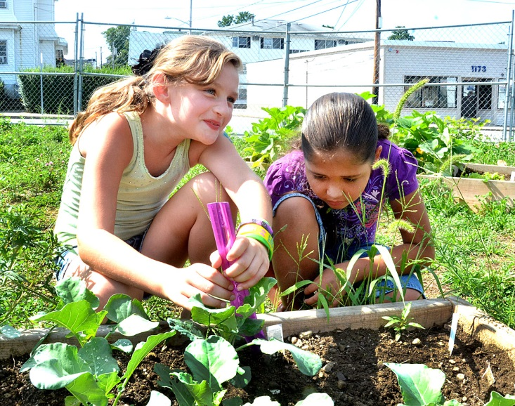
Good nutrition is essential for health. Insufficient nutrition can hinder growth and development. Excessive calorie consumption, however, can lead to overweight and obesity, especially when paired with too little physical activity. Inadequate physical activity itself also contributes to increased risk of a number of conditions including coronary heart disease, diabetes, and some cancers .
Healthy food and regular exercise are important to health. Yet, half of adults and nearly 72% of high school students in the US do not meet the CDC’s recommend physical activity levels, and American adults walk less than adults in any other industrialized country. As of 2013, 29 million Americans lived in a food desert, without access to affordable, healthy food. Those with lower education levels, already at-risk for poor health outcomes, frequently live in food deserts .
More than two-thirds of all American adults and approximately 32% of children and adolescents are overweight or obese. Obesity is one of the biggest drivers of preventable chronic diseases in the US. Being overweight or obese increases the risk for many health conditions, including type 2 diabetes, heart disease, stroke, hypertension, cancer, Alzheimer’s disease, dementia, liver disease, kidney disease, osteoarthritis, and respiratory problems. Unhealthy food intake and insufficient exercise have economic impacts for individuals and communities. Current estimates for obesity-related health care costs in the US range from $147 billion to nearly $210 billion annually, and productivity losses due to job absenteeism cost an additional $4 billion each year.
Increasing opportunities for exercise and access to healthy foods in neighborhoods, schools, and workplaces can help children and adults eat healthy meals and reach recommended daily physical activity levels.
Health Behaviors
Health behavior is defined as the actions taken by individuals or groups thereof to change or maintain their health status or to prevent illness or injury. This category includes behaviors related to healthy eating and active living, and highlights include:
- Across the region, fewer than half of all adults reported engaging in physical activity for exercise regularly: just 45.7% in Greater Fall River compared to 53.0% in Massachusetts.
- Over three-quarters of South Coast adults do not consume the recommended five servings daily of fruit and vegetables. In Greater Fall River, a slightly higher percent of adults (19.9%) consume the recommended servings, compared to 18.8% of residents statewide.
- Since 2000, the population of South Coast adults who are overweight or obese has increased dramatically in Fall River. As of 2011, 65.7% of Greater Fall River adults were overweight (defined as having a Body Mass Index of more than 25). Approximately half of this group weighed enough to qualify as obese (BMI>30).
Nutrition
Over three-quarters of South Coast adults do not consume the recommended five servings daily of fruit and vegetables, but in Greater Fall River, 19.9% of adults consume the recommended servings, compared to 18.8% of residents statewide . It should also be noted that the proportion of adults in the region (and in Massachusetts) who consume the recommended servings of fruit and vegetables has declined since 2000.
Physical activity
Higher rates of the region’s adults engaged in physical activity for exercise over the span of a month: 73.1% of those in Greater New Bedford and 65.5% of Greater Fall River residents, compared to 76.5% of Massachusetts adults as a whole. Adults in the City of Fall River exercise at particularly low rates, with just 55.9% reporting engaging in exercise in the past month. Across the region, fewer than half of all adults reported engaging in physical activity for exercise regularly: just 45.7% in Greater Fall River and 49.5% in Greater New Bedford, compared to 53.0% in Massachusetts .

Diet and physical activity
Fall River CHNA 25 SE Mass. Mass.
Diet of Fruits and Vegetables, 5+/day 21 21.9 27.4 28.7
Regular Physical Activity 44.8 47.1 51.8 52.1
Any Physical Activity for Exercise in Past Month 64.6% 68.4 77.5 78.7
Behavioral Risk Factor Surveillance System (BRFSS) 2002-2007
Healthy Weight
The ability to maintain a healthy weight is both a health behavior and a health outcome associated with nutrition and physical activity. Since 2000, the population of South Coast adults who are overweight or obese has increased dramatically. As of 2011, 63.1% of Greater Fall River adults were overweight (defined as having a Body Mass Index of more than 25). Approximately half of this group (32.2%) in Greater Fall River weighed enough to qualify as obese (BMI>30). Comparatively, 59.3% of Massachusetts adults were overweight in 2010, and 22.7% were obese (see Graph 17).
Healthy Weight
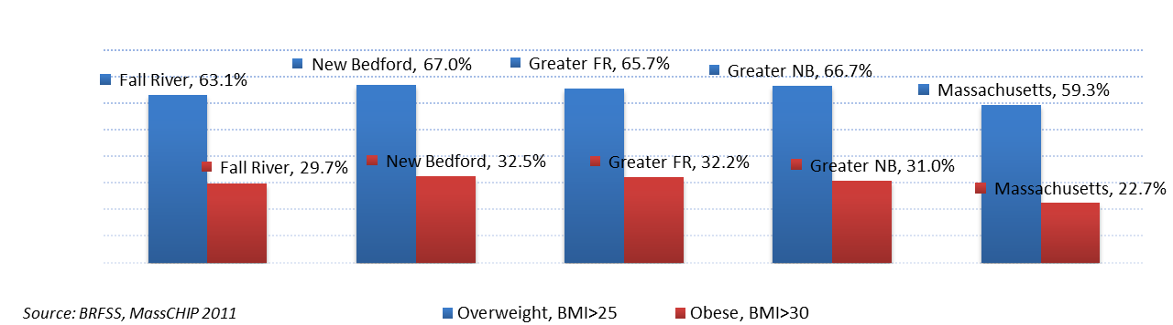
Regular physical activity, which is an essential component to weight loss and managing chronic diseases, is practiced by 44.8% of adults in Fall River. While this percentage is much lower than the state’s (52.1%), it is significantly higher than the national percentage of 20.4%. A recent report indicates that certain sections of Fall River have even higher obesity prevalence than the citywide number reported by MDPH. The city’s south and east ends have the lowest income residents and the largest immigrant population, and were classified as high priority communities in the state based on obesity prevalence rates and higher risks for chronic diseases such as diabetes and hypertension.
Overweight and obesity among school age children was measured in grades 1, 4, 7 and 10 from school years 2003-2004 to 2009-2010. BMI averages were calculated per grade and gender and percentages of each category: underweight, normal, overweight, and obese were calculated. The percentages of overweight and obese children were calculated for each grade (where data was available) and the school year average of overweight/obese children for the entire sample was determined.
Though the 2009 statewide report showed slightly lower rates for Fall River school children, there was a conspicuous trend of increasing overweight/obese BMI values from School Year 2003-2004 to 2009-2010. The data suggests a progressive increase in the proportion of children categorized as being overweight and obese. The overweight/obese category BMI average for this sample was at its lowest at 21% in the School Year 2006-2007, progressing to a recent high of 38% which demonstrates an increase of 80% in a three year span.

Health Factor I: | Diet & Exercise | Problems with poor diet, inactivity, and lack of knowledge of and access to healthy food |  | Goal: | To lower diabetes, heart disease, some cancers rates
Problem Area | Strategic Goal | Strategy | Activity | Resources | Measures | Achieved
Population Nutrition is poor, obesity and diabetes rates are high | Increase rate of fruit and vegetable consumption | Increase the availability of healthy produce | Increase outlets which offer healthy produce | Increase access and availability of farmers' markets | Number of hours markets are open and number of locations | Count hours and locations
1:

Health Factor I: | Diet & Exercise | Problems with poor diet, inactivity, and lack of knowledge of and access to healthy food |  | Goal: | To lower diabetes, heart disease, some cancers rates
Problem Area | Strategic Goal | Strategy | Activity | Resources | Measures | Achieved
Population Nutrition is poor, obesity and diabetes rates are high | Increase rate of fruit and vegetable consumption | Increase the availability of healthy produce | Increase outlets which offer healthy produce | Mass in Motion Healthy Neighborhood Market expansion | Increase number of markets offering healthy produce | Count of markets offering health produce
2:

Health Factor I: | Diet & Exercise | Problems with poor diet, inactivity, and lack of knowledge of and access to healthy food |  | Goal: | To lower diabetes, heart disease, some cancers rates
Problem Area | Strategic Goal | Strategy | Activity | Resources | Measures | Achieved
Population Nutrition is poor, obesity and diabetes rates are high | Increase rate of fruit and vegetable consumption | Increase number of school and community gardens | Work with school and organization staff with an interest in gardens | Link experienced gardeners with those willing to learn | Number of gardens and gardeners | Count of gardens and gardeners
3:

Health Factor I: | Diet & Exercise | Problems with poor diet, inactivity, and lack of knowledge of and access to healthy food |  | Goal: | To lower diabetes, heart disease, some cancers rates
Problem Area | Strategic Goal | Strategy | Activity | Resources | Measures | Achieved
Population Nutrition is poor, obesity and diabetes rates are high | Increase rate of fruit and vegetable consumption | Create permaculture gardens throughout the community | Plan, organize, create and maintain plantings | Mass in Motion grant, Permaculture expert | Number of plantings | Count of plantings
4:

Health Factor I: | Diet & Exercise | Problems with poor diet, inactivity, and lack of knowledge of and access to healthy food |  | Goal: | To lower diabetes, heart disease, some cancers rates
Problem Area | Strategic Goal | Strategy | Activity | Resources | Measures | Achieved
Population Nutrition is poor, obesity and diabetes rates are high | Increase rate of fruit and vegetable consumption | Increase education around the selection and preparation of healthy produce | Expand nutrition education opportunities | Umass-Amherst Nutrition Education Program staff | Increased number of locations where nutrition education is offered | Count of nutrition education opportunities
5:

Health Factor I: | Diet & Exercise | Problems with poor diet, inactivity, and lack of knowledge of and access to healthy food |  | Goal: | To lower diabetes, heart disease, some cancers rates
Problem Area | Strategic Goal | Strategy | Activity | Resources | Measures | Achieved
Population Nutrition is poor, obesity and diabetes rates are high | Improve the quality of food offered at work locations | Educate and incentivize employers to adopt healthy nutrition policies | Introduce healthy workplace nutrition guidelines to local employers | Partners educational materials; Worksite Wellness Coordinator's time | Number of employers that adopt healthy worksite nutrition policies | Count of worksites with healthy nutrition policies
6:

Health Factor I: | Diet & Exercise | Problems with poor diet, inactivity, and lack of knowledge of and access to healthy food |  | Goal: | To lower diabetes, heart disease, some cancers rates
Problem Area | Strategic Goal | Strategy | Activity | Resources | Measures | Achieved
Population Nutrition is poor, obesity and diabetes rates are high | Improve the quality of food offered in public and private schools | Educate and incentivize school systems to adopt healthy nutrtion policies | Work with School Wellness Policy development teams to address nutrtion guidelines | School Wellness Coordinator's time | Number of school systems that adopt health nutrition policies | Count of school systems
7:

Health Factor I: | Diet & Exercise | Problems with poor diet, inactivity, and lack of knowledge of and access to healthy food |  | Goal: | To lower diabetes, heart disease, some cancers rates
Problem Area | Strategic Goal | Strategy | Activity | Resources | Measures | Achieved
Population Nutrition is poor, obesity and diabetes rates are high | Improve the quality of food offered in civic and religious organizations | Educate and incentivize civic and religious organizations to adopt healthy nutrition policies | Work with civic and religious organizations to adopt healthy nutrition policies | Healthy City Fall River Coordinator's time | Number of civic and religious organizations that adopt | Count of organizations
8:

Health Factor I: | Diet & Exercise | Problems with poor diet, inactivity, and lack of knowledge of and access to healthy food |  | Goal: | To lower diabetes, heart disease, some cancers rates
Problem Area | Strategic Goal | Strategy | Activity | Resources | Measures | Achieved
Population Nutrition is poor, obesity and diabetes rates are high | Increase the availability of nutrition education opportunities | Arrange for nutrition education, especially for low-income and special populations at-risk of nutrition problems | Offer teaching opportunities at soup kitchens and food distribution sites | Voluntary instructors from BCC, Johnson & Wales, and Umass-Amherst Nutrition Education Program | Number and locations of nutrition education opportunities offered | Count of nutrition activities offered
9:

Health Factor I: | Diet & Exercise | Problems with poor diet, inactivity, and lack of knowledge of and access to healthy food |  | Goal: | To lower diabetes, heart disease, some cancers rates
Problem Area | Strategic Goal | Strategy | Activity | Resources | Measures | Achieved
Population Nutrition is poor, obesity and diabetes rates are high | Increase the availability of nutrition education opportunities | Promote the "Look Who's Cooking" Series | Advertise series through multiple outlets | Community Media on-line service and CDs distributed widely | Frequency of views | Count of views
10:

Health Factor I: | Diet & Exercise | Problems with poor diet, inactivity, and lack of knowledge of and access to healthy food |  | Goal: | To lower diabetes, heart disease, some cancers rates
Problem Area | Strategic Goal | Strategy | Activity | Resources | Measures | Achieved
Population Nutrition is poor, obesity and diabetes rates are high | Increase the availability of nutrition education opportunities | Promote Family Fun Night nutrition education | Promote Family Fun Nights in all elementary schools | Local nutrition educators | Numbers of attendees | Count of attendance
11:

Health Factor I: | Diet & Exercise | Problems with poor diet, inactivity, and lack of knowledge of and access to healthy food |  | Goal: | To lower diabetes, heart disease, some cancers rates
Problem Area | Strategic Goal | Strategy | Activity | Resources | Measures | Achieved
Population Nutrition is poor, obesity and diabetes rates are high | Increase the availability of nutrition education opportunities | Promote nutrition education opportunities for those with diabetes and prediabetes | Hold cooking demonstrations at a variety of venues | People Incorporated Diabetes Association staff | Numbers of attendees | Count of attendance
12:

Health Factor I: | Diet & Exercise | Problems with poor diet, inactivity, and lack of knowledge of and access to healthy food |  | Goal: | To lower diabetes, heart disease, some cancers rates
Problem Area | Strategic Goal | Strategy | Activity | Resources | Measures | Achieved
Population Nutrition is poor, obesity and diabetes rates are high | Increase the availability of nutrition education opportunities | Promote WIC "Cooking Matters" and shopping tour program to 3,000+ enrollees | Hold cooking and shopping demonstrations at a variety of venues | HealthFirst WIC program staff | Number of attendees | Count of events and attendees
13:

Health Factor I: | Diet & Exercise | Problems with poor diet, inactivity, and lack of knowledge of and access to healthy food |  | Goal: | To lower diabetes, heart disease, some cancers rates
Problem Area | Strategic Goal | Strategy | Activity | Resources | Measures | Achieved
Population fitness levels are low; too few people get the recommended hours of moderate physical activity per week | Increase the availability of organized fitness activities throughout the community | Organize, promote and operate a year-around Fitness Challenge for residents for the Greater Fall River Area | Engage voluntary participation of professional fitness providers; fund-raise for incentives | Partners paid coordinator's time to organize and promote Challenge | Number of attendees for each event and event totals | Count of participants
14:

Health Factor I: | Diet & Exercise | Problems with poor diet, inactivity, and lack of knowledge of and access to healthy food |  | Goal: | To lower diabetes, heart disease, some cancers rates
Problem Area | Strategic Goal | Strategy | Activity | Resources | Measures | Achieved
Population fitness levels are low; too few people get the recommended hours of moderate physical activity per week | Increase the availability of organized fitness activities throughout the community | Organize and promote a school-based Challenge series for local schools | Engage voluntary participation of physical education teachers and principals | Partners School Wellness Coordinator's time | Number of children participating | Count of teachers and child participants
15:

Health Factor I: | Diet & Exercise | Problems with poor diet, inactivity, and lack of knowledge of and access to healthy food |  | Goal: | To lower diabetes, heart disease, some cancers rates
Problem Area | Strategic Goal | Strategy | Activity | Resources | Measures | Achieved
Population fitness levels are low; too few people get the recommended hours of moderate physical activity per week | Increase the availability of organized fitness activities throughout the community | Organize a Safe-Routes-To-School Walking program at elementary schools | Engage parent volunteers, principals, teachers and community health workers | Partners School Wellness Coordinator's time | Number of children participating | Count of teachers and child participants
16:

Health Factor I: | Diet & Exercise | Problems with poor diet, inactivity, and lack of knowledge of and access to healthy food |  | Goal: | To lower diabetes, heart disease, some cancers rates
Problem Area | Strategic Goal | Strategy | Activity | Resources | Measures | Achieved
Population fitness levels are low; too few people get the recommended hours of moderate physical activity per week | Increase the availability of organized fitness activities throughout the community | Engage behavioral health clients in a program of regular exercise | Organize and operate a daily fitness program at the SSTAR Outpatient Program | SSTAR staff | Number of participants and frequency of sessions | Count of sessions and participants
17:

Health Factor I: | Diet & Exercise | Problems with poor diet, inactivity, and lack of knowledge of and access to healthy food |  | Goal: | To lower diabetes, heart disease, some cancers rates
Problem Area | Strategic Goal | Strategy | Activity | Resources | Measures | Achieved
Population fitness levels are low; too few people get the recommended hours of moderate physical activity per week | Increase the availability of organized fitness activities throughout the community | Engage housing authority residents in a program of regular exercise | Run a wellness program that includes regular physical activity for adults and children | SCHHWI staff | Number of participants and frequency of sessions | Count of sessions and participants
18:

Health Factor I: | Diet & Exercise | Problems with poor diet, inactivity, and lack of knowledge of and access to healthy food |  | Goal: | To lower diabetes, heart disease, some cancers rates
Problem Area | Strategic Goal | Strategy | Activity | Resources | Measures | Achieved
Population fitness levels are low; too few people get the recommended hours of moderate physical activity per week | Increase the availability of organized fitness activities throughout the community | Engage new moms in a program of regular exercise | Run a FitWIC program at HealthFirst | WIC staff | Number of participants and frequency of sessions | Count of sessions and participants
19:

Health Factor I: | Diet & Exercise | Problems with poor diet, inactivity, and lack of knowledge of and access to healthy food |  | Goal: | To lower diabetes, heart disease, some cancers rates
Problem Area | Strategic Goal | Strategy | Activity | Resources | Measures | Achieved
Population fitness levels are low; too few people get the recommended hours of moderate physical activity per week | Increase the availability of organized fitness activities throughout the community | Operate a program at Bristol Community College that engages students in physical exercise | Operate a physical fitness program in the Commonwealth Center open to all students | Bristol Community College staff | Number of participants and frequency of sessions | Count of sessions and participants
20:

Health Factor I: | Diet & Exercise | Problems with poor diet, inactivity, and lack of knowledge of and access to healthy food |  | Goal: | To lower diabetes, heart disease, some cancers rates
Problem Area | Strategic Goal | Strategy | Activity | Resources | Measures | Achieved
Population fitness levels are low; too few people get the recommended hours of moderate physical activity per week | Increase the availability of organized fitness activities throughout the community | Run a weekly fitness program for seniors designed to increase balance, flexibility and strength | Run two groups at the Niagara Senior Center on a weekly basis | Senior Center staff and YMCA instructor | Number of participants and frequency of sessions | Count of sessions and participants
21:

Health Factor I: | Diet & Exercise | Problems with poor diet, inactivity, and lack of knowledge of and access to healthy food |  | Goal: | To lower diabetes, heart disease, some cancers rates
Problem Area | Strategic Goal | Strategy | Activity | Resources | Measures | Achieved
Population fitness levels are low; too few people get the recommended hours of moderate physical activity per week | Create a walking map of Central Fall River showing distances between points and walking times | Increase knowledge of walkability of Central Fall River | Print and distribute maps widely; hold promotional events to encourage walking | Mass In Motion Coordinator and BikeFall River volunteers | Numbers of maps printed and distributed | Count of number of maps printed and distributed
22:

Health Factor I: | Diet & Exercise | Problems with poor diet, inactivity, and lack of knowledge of and access to healthy food |  | Goal: | To lower diabetes, heart disease, some cancers rates
Problem Area | Strategic Goal | Strategy | Activity | Resources | Measures | Achieved
Population fitness levels are low; too few people get the recommended hours of moderate physical activity per week | Promote increased safe use of bicycles by children | Organize programs to teach bicycle safety | Offer bicycle safety training classes; distribute free helmets | Mass In Motion Coordinator and BikeFall River volunteers | Numbers of participants and helmets distributed | Count of participants and helmets
23:

Health Factor I: | Diet & Exercise | Problems with poor diet, inactivity, and lack of knowledge of and access to healthy food |  | Goal: | To lower diabetes, heart disease, some cancers rates
Problem Area | Strategic Goal | Strategy | Activity | Resources | Measures | Achieved
Population fitness levels are low; too few people get the recommended hours of moderate physical activity per week | Promote personal engagement in fitness through a community campaign | Plan, organize, and promote a personal "Get Fit" program for the community | Hold events to promote personal fitness; advertise the benefits of fitness widely | Healthy City Fall River Coordinator's time | Numbers of events and participants | Count of events and attendees
24:

Healthy Factor II: Tobacco, Alcohol and Other Drug Use Prevention
Smoking is much more prevalent among South Coast adults as compared to incidence of this behavior statewide. More than a quarter of adults in the region are current smokers compared to less than twenty percent statewide. Smoking is most prevalent in New Bedford where 31.8% of adults are current smokers. Graph A illustrates current smoking behavior across the region.
Secondhand smoke exposure is also more prevalent in our region with almost one-quarter of South Coast adults allowing smoking in their home: while just 19.5% of Massachusetts residents allow smoking in their homes either sometimes or always, 29.4% of Greater Fall River residents allow this exposure to secondhand smoke.
Smoking Prevalence
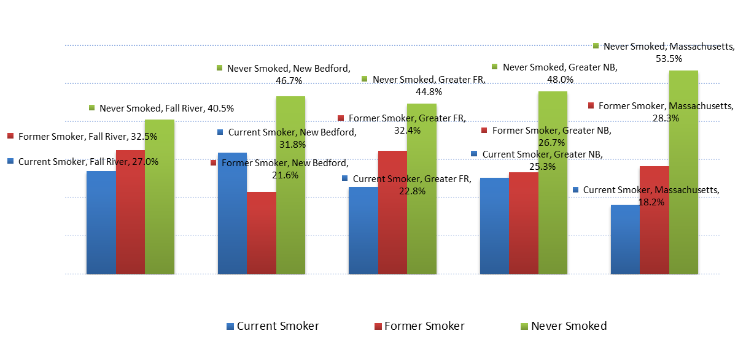

South Coast residents exhibit similar patterns of alcohol use as residents of Massachusetts as a whole. The proportion of adults who report binge drinking (defined as consuming 5+ drinks on an occasion for men or 4+ drinks for women) within the past 30 days is 18.2% in Greater Fall River and 16.7% in Greater New Bedford (17.8% is the statewide rate).
Rates of heavy drinking, or consuming an average of more than two drinks per day (men) or more than one drink per day (women), are actually slightly lower in the South Coast as compared to Massachusetts. The proportion of adults who report drinking this amount regularly is 6.6% in Greater Fall River and 5.9% in Greater New Bedford, compared to 6.7% across the state.
Data is available to measure admissions to Department of Public Health funded substance abuse treatment programs among males and females ages 15-19. While hospitalizations in the region are comparatively lower than statewide rates, substance abuse treatment admissions are generally above state levels. Among males, rates per 100,000 for males ages 15-19 are 1,401 in Greater Fall River and 1,265 in Massachusetts. Among females, rates are 1,315 in Greater Fall River and 700 in Massachusetts.
In FY 2012, there were 104,224 admissions to substance abuse treatment programs statewide; 3.45% (3,595) of these admissions reported being from the City of Fall River. 1.53% (55) of admissions from the City of Fall River were under 18 years of age. (Note that these statistics represent admissions to treatment and not distinct individuals.)
In FY 2012, adult admissions to substance abuse treatment services from the City of Fall River reported the following characteristics:
- 67% were male and 33% were female.
- 67% were between the ages of 21-39.
- 89% were white, 3% were black, 4% were multi-racial and 5% were of other single race.
- 5% were Hispanic.
- 71% were never married, 8% were married, and 21% reported not to be married now.
- 35% had less than high school education, 43% completed high school, and 21% had more than high school education.
- 12% were employed.
- 24% were homeless.
- 54% had prior mental health treatment
Health Factor II: | Tobacco, Alcohol and Other Drug Use Prevention | Smoking, prescription and illegal drug use |  | Goal: | Reduced smoking rates, less drug or alcohol addiction, fewer overdoses
Problem Area | Strategic Goal | Strategy | Activity | Resources | Measures | Achieved
Opiod overdose deaths are rising | Reduce opioid overdoses and deaths resulting by making Narcan more readily available | Permit law enforcement officers to carry Narcan kits and train in its administration | Equip and train local law enforcement officers | State funding provided through Seven Hills | Number of officers trained | Count of officers trained
25:

Health Factor II: | Tobacco, Alcohol and Other Drug Use Prevention | Smoking, prescription and illegal drug use |  | Goal: | Reduced smoking rates, less drug or alcohol addiction, fewer overdoses
Problem Area | Strategic Goal | Strategy | Activity | Resources | Measures | Achieved
Opiod overdose deaths are rising | Expand drug courts in Fall River | Fund and authorize a drug court in Fall River | Secure funding and authorization | State funding for a local drug court | Drug court operational | Evidence of drug court operations
26:

Health Factor II: | Tobacco, Alcohol and Other Drug Use Prevention | Smoking, prescription and illegal drug use |  | Goal: | Reduced smoking rates, less drug or alcohol addiction, fewer overdoses
Problem Area | Strategic Goal | Strategy | Activity | Resources | Measures | Achieved
Track substance abuse related problems in surrounding towns | Administer the YRBS in Somerset, Swansea and Westport | Offer additional programs to reach youth in Somerset, Swansea and Westport | Arrange and provide educational presentations in youth agencies and schools | BSAS funding through a variety of local grants | Number of educational presentation | Count of presentations
27:

Health Factor II: | Tobacco, Alcohol and Other Drug Use Prevention | Smoking, prescription and illegal drug use |  | Goal: | Reduced smoking rates, less drug or alcohol addiction, fewer overdoses
Problem Area | Strategic Goal | Strategy | Activity | Resources | Measures | Achieved
Track substance abuse related problems in surrounding towns | Administer the YRBS in Somerset, Swansea and Westport | Work with local school committees and town councils to ensure funding and administration | Run a YRBS and Youth Health Survey in all public schools | Grant funding and support from Partners if needed | Offer YRBS and YHS in each school at least every other year | Evidence of surveys offered
28:

Health Factor II: | Tobacco, Alcohol and Other Drug Use Prevention | Smoking, prescription and illegal drug use |  | Goal: | Reduced smoking rates, less drug or alcohol addiction, fewer overdoses
Problem Area | Strategic Goal | Strategy | Activity | Resources | Measures | Achieved
Tobacco use is high among youth | Provide compliance checks of vendors in all area towns | Provide ongoing "stings" in each of the four towns | Provide random compliance checks of all area tobacco vendors | BSAS funding through a variety of local grants | Compliance checks administered among local tobacco vendors | Number of compliance checks; number of violations and Board of Health sanctions
29:

Health Factor II: | Tobacco, Alcohol and Other Drug Use Prevention | Smoking, prescription and illegal drug use |  | Goal: | Reduced smoking rates, less drug or alcohol addiction, fewer overdoses
Problem Area | Strategic Goal | Strategy | Activity | Resources | Measures | Achieved
Tobacco use is high among youth | Provide compliance checks of vendors in all area towns | Increase uniformity of compliance checks across the four towns | Work with Boards of Health and Selectmen to create uniform procedures | BSAS funding through a variety of local grants | Compliance checks administered among local tobacco vendors | Number of compliance checks; number of violations and Board of Health sanctions
30:

Health Factor II: | Tobacco, Alcohol and Other Drug Use Prevention | Smoking, prescription and illegal drug use |  | Goal: | Reduced smoking rates, less drug or alcohol addiction, fewer overdoses
Problem Area | Strategic Goal | Strategy | Activity | Resources | Measures | Achieved
Tobacco use is high among youth | Increase educational offerings to youth | Establish The84.org chapters in all four towns | Work with local schools to create organizations | BSAS funding through a variety of local grants; Partners funding if needed; Life together fellows | The number of The84.org chapters established | Count of The84.org chapters
31:

Health Factor III: Sexual Activity and Infectious Diseases



Teen births in Fall River have been historically higher than both regional and statewide figures over the past twenty years. In the same time period, prenatal care has lagged behind state rates, and maternal smoking rates have been very high, resulting in lower birth weights. Fetal and infant health indicators relate to care, maternal behavior, and outcomes. In both Greater Fall River and Greater New Bedford, levels of care and outcomes are generally suboptimal compared to Massachusetts. First, fewer infants’ mothers begin prenatal care during the first trimester: 81.2% in Greater Fall River and 76.5% in Greater New Bedford, compared to 83.0% statewide
Fall River ranks among the top ten cities in the Commonwealth of Massachusetts where HIV infection is linked to injection drug use. There are 221 people living with HIV/AIDS in the city. The most reported mode of transmission for individuals with HIV in the area is injection drug use. According to SSTAR’s (Does SSTAR need to be spelled out here too?) data on HIV testing, 82% of those tested identify as an injection drug user (IDU) or a partner of an IDU (01/01/10 CMAR data). An additional 8% identify as the partner of a person living (Both lower case or is that consider a proper noun title?) with HIV/AIDS. While AIDS and HIV-related deaths are twice the crude rate of the state, other infectious diseases in Greater Fall River are well below state rates.

Health Factor III: | Sexual Activity and Infectious Diseases | Problems with STDs, HIV, teen pregnancy |  | Goal: | Less infertility, AIDS, premature parenting
Problem Area | Strategic Goal | Strategy | Activity | Resources | Measures | Achieved
Teen pregnancy rates are higher than state averages | Continue after-school, peer-led programs in all area schools | Offer peer-led programs, counseling and resources in all schools | Offer PREP Program at Youth Build, BCC Gateway Program, etc. | DPH funding for teen pregnancy prevention | The number of peer-led programs offered | Count of peer-led programs
32:

Health Factor III: | Sexual Activity and Infectious Diseases | Problems with STDs, HIV, teen pregnancy |  | Goal: | Less infertility, AIDS, premature parenting
Problem Area | Strategic Goal | Strategy | Activity | Resources | Measures | Achieved
STDs (Clamidia, Syphilis, Gonnoreha) rates continue to rise | Increase screenings for STDs at all medical facilities | Incentivize both patients and physicians to prerform screenings on a routine basis | Provide educational programs for both professionals and patients | DPH funding for teen pregnancy prevention | The number of educational offerings | Count of educational offerings
33:

Health Factor III: | Sexual Activity and Infectious Diseases | Problems with STDs, HIV, teen pregnancy |  | Goal: | Less infertility, AIDS, premature parenting
Problem Area | Strategic Goal | Strategy | Activity | Resources | Measures | Achieved
HIV/AIDs rates continue at a steady rate | Ensure continuation of educational efforts | Advocate for continued funding after expiration of Ryan White funding | Advocate for continued funding through DPH | Organize local advocacy efforts | Evidence of advocacy for continued funding | Descriptions of advocacy efforts
34:

Health Factor IV: Access to Quality Dental, Health, Mental Health and Substance Abuse Care
Generally speaking, South Coast residents have access to care that is comparable to residents of Massachusetts , and when it comes to having a relationship with a care provider, residents of the South Coast are well served :
- 87.1% of Greater Fall River residents reported having a personal health care provider, compared to 87.8% of residents statewide. However, the number of Fall River residents (84.5%) who have a personal health care provider is below the state level.
- 86.2% of adults in Fall River and 89.1% in Greater Fall River have had a checkup in the past year which is somewhat greater than the statewide average of 78.8%. Access to care is determined according to the following indicators: percentage of adults with a personal health care provider, percentage of adults who could not see a doctor due to cost, and percentage of adults who had a checkup in the past year.
- Similarly, the proportion of South Coast adults as a whole who report being unable to see a doctor due to cost has declined over the past decade for each of these areas. As with many of the health indicators this assessment is measuring, however, residents in Fall River have greater barriers to care.
Dental health, and gum disease in particular, is linked to health outcomes like diabetes, heart disease, and stroke, and maternal dental health is shown to affect neonatal outcomes. Limited data is available to gauge access to dental care in the South Coast, but that which is available indicates that the region is underserved in this area. While 77.8% of Massachusetts residents reported a dental visit in the past year, just 66.4 % of Fall River residents visited a dentist. In Bristol County, which encompasses Fall River and New Bedford, the rate was 75%, while the state average was 83 %.
Depression is one of the most common complications of chronic disease. It is estimated that up to one-third of individuals with a serious medical condition experience symptoms of depression. In some cases, the occurrence, management, and progression of a chronic disease can trigger clinically significant depression. According to the most recent Behavioral Risk Factor Surveillance System (BRFSS), a high percentage of Fall River residents reported experiencing poor mental health and depression compared to the county, state and nation. The suicide rate for the area is slightly higher than the state but less than the other two comparable geographic areas. MDPH data found that 55% of suicide victims had a mental health problem, 29% had a history of substance or alcohol abuse and 22% had a job loss or financial problems.
High unemployment and loss of insurance due to job loss have affected residents’ ability to access health care. Data from the Behavioral Risk Factor Statewide Survey (BFRSS) indicates a high percentage of residents report they could not see a physician due to cost (10.9% verses 7.0% for the state).
While Fall River can be characterized as an urban area, its public transportation service does not reflect that of an urban center. Access to reliable and affordable public transportation for the city is limited and does not meet the needs of the community. In 2010, the Southeastern Massachusetts Transportation Alliance conducted a focus group on the transportation needs of Fall River and surrounding communities. The study found that the existing transit system covers a limited geographic area and that cost is a major barrier for residents that need to access public transportation. For example, residents reported that students with no income, who are self-reliant to get to school, couldn’t afford the bus. If they need to transfer buses to get to the high school, it costs them $2 per day to get to school. Transportation barriers have also posed a challenge to the patients we serve and have had an adverse effect on health outcomes among this population.
Through needs assessment, we have learned that transportation is a major barrier for the parents of our pediatric patients. Access to affordable and reliable transportation has always been a challenge for many of our patients, but over the past year, it has become an even greater obstacle due to the high unemployment rate.
HealthFirst Family Care Center and SSTAR Family Health Clinic have a long and proud history of providing interpreter services for our ethnic populations. We have accomplished this by recruiting bi/tri-lingual speaking staff and contracting with a telephone language line which offers interpreting services in over 50 languages, 24 hours a day, seven days a week. An increase in the Hispanic population in the area and deaf patients being seen at the health centers have placed a greater demand for Spanish and deaf interpreters. We are finding it challenging to recruit professional medical interpreters for Spanish speakers and hard of hearing patients.

Health Factor IV: | Access to Quality Dental, Health, Mental Health and Substance Abuse Care | Problems with insurance coverage, waiting times, lack of support outside medical settings |  | Goal: | Less delayed or inappropriate treatment, oral pain, stress, depression and other mental health disorders
Problem Area | Strategic Goal | Strategy | Activity | Resources | Measures | Achieved
Population experiences high rates of chronic depression and other mental health disorders | Increase access to behavioral health resources throughout the region | Increase the availability of mental health services and providers | Advocate for improved reimbursement rates and coverage of wrap-around services | Southcoast Hospitals PACT program employees to organize advocacy effort | Numbers of persons involved in the advocacy process; increase in reimbursement rates; expansion of coverage to include wrap-around | Count of persons; documentation of rate increase and coverage expansion
35:

Health Factor IV: | Access to Quality Dental, Health, Mental Health and Substance Abuse Care | Problems with insurance coverage, waiting times, lack of support outside medical settings |  | Goal: | Less delayed or inappropriate treatment, oral pain, stress, depression and other mental health disorders
Problem Area | Strategic Goal | Strategy | Activity | Resources | Measures | Achieved
Population experiences high rates of chronic depression and other mental health disorders | Increase access to behavioral health resources throughout the region | Development of a single intake and screening tool to identify needs for services that could be universally used by multiple agencies and service providers | Develop prototype of an inter-agency referral tool to be used by multiple service providers | Prevention and Wellness Trust Fund SHIFT Project for two zip codes each in Fall River and New Bedford | Development of electronic referral system | Documentation of electronic referral system developed in conjunction with MA DPH
36:

Health Factor IV: | Access to Quality Dental, Health, Mental Health and Substance Abuse Care | Problems with insurance coverage, waiting times, lack of support outside medical settings |  | Goal: | Less delayed or inappropriate treatment, oral pain, stress, depression and other mental health disorders
Problem Area | Strategic Goal | Strategy | Activity | Resources | Measures | Achieved
Population experiences high rate of poor dental hygiene | Provide education, especially to parents and children to teach dental hygiene | Increase the numbers of presentations on dental health at public venues | Include dental hygiene education in all Partners tableing events | HealthFirst Dental Hygiene Program | Numbers of presentations to parents and children in public venues | Count of presentations
37:

Health Factor IV: | Access to Quality Dental, Health, Mental Health and Substance Abuse Care | Problems with insurance coverage, waiting times, lack of support outside medical settings |  | Goal: | Less delayed or inappropriate treatment, oral pain, stress, depression and other mental health disorders
Problem Area | Strategic Goal | Strategy | Activity | Resources | Measures | Achieved
Public transportation system makes accessing medical, dental and behavioral health services difficult | Reform current SRTA bus system to make it more responsive to consumer needs | Make route and schedule changes and add Saturday and Sunday hours; eliminate language barriers | Advocate for improved transportation system through local groups | Coalition for Social Justice; United Interfaith Action | Improvements in bus schedule and routes | Documentation of schedule and route changes
38:

Health Factor V: Education, Employment, Income and Disability


In terms of clinical care disparities based on income, perhaps unsurprisingly, access to and utilization of clinical care is more challenging to the South Coast’s lower income residents as compared to those earning more than $50,000 per year. For example, across the board, a greater percentage of those with higher incomes have participated in health screenings, which mirrors statewide breakdowns between income groups. But in some cases, even fewer of the South Coast’s lower income residents engage in screenings than their lower income counterparts across Massachusetts, including breast exams, pap smears, and colonoscopies.

Since education levels are correlated with income levels, it follows that among those with lower levels of educational attainment, there is less access to clinical care. Among those without a college degree, many more cannot see a doctor due to cost.

- Where participation in screening is concerned, some education-specific disparities include lower rates of clinical breast exams in Greater Fall River, (where just 75% of this subgroup reports having had this exam), pap smears, and colonoscopies among those without a college degree.
- Approximately four times as many South Coast adults who earn less than $50,000 per year report having fair or poor health as compared to those who earn above that threshold. In Greater Fall River, 25.0% of low-income earners report having fair or poor health compared to 6.2% of higher earners.
- A significant difference in general health exists between those with and without a college degree; while fewer than nine percent of those with a degree report having fair or poor health, 27.1% in Greater Fall River of those with a high school degree or less report having fair or poor health.

Poverty is one of the primary social determinants of health. Fall River has one of the highest poverty rates in the state: 21.4% of Fall River residents are below the U.S. Census Bureau’s poverty threshold, which compares to 14.5% for the South Coast and 10.7% statewide. Importantly, not only does Fall River have the highest poverty rates in the region, but Fall River and New Bedford together also account for the majority of the region’s poor in absolute numbers. Family poverty levels in the South Coast as a whole are higher than the state average with rates highest in the region’s cities.

- 11.5% of South Coast families live below the federal poverty level compared to 7.6% of families statewide.
- 19.1% of South Coast families with children live below the federal poverty level compared to 11.8% of families statewide.
- 32.1% of South Coast female headed by females live below the federal poverty level compared to24.5% statewide.

Average unemployment rates in the region are historically higher than the statewide average throughout the business cycle with much of the difference driven by high unemployment rates in Fall River and New Bedford. While the region’s unemployment rate declined steadily during the 1990s and slowly closed the gap with the statewide unemployment rate, this gap is beginning to increase once again. The 2012 annual average unemployment rate in the South Coast was 10.4%, which compares to a statewide average unemployment rate of 6.7% and a national rate of 8.1%.The annual unemployment rate in Fall River of 13.0% was significantly higher than the state average in 2012.

Families Below Poverty
Families Below Poverty Level
 | Town/City | Enroll | Low Income | # Families | Families<Poverty | Percent
 | Fall River | 12,104 | 6,079 | 22,270 | 4,120 | 18.5%
 | New Bedford | 14,609 | 8,431 | 23,627 | 4,418 | 18.7%
 | Somerset | 2,844 | 264 | 4,851 | 116 | 2.4%
 | Swansea | 2,295 | 283 | 4,666 | 135 | 2.9%
 | Westport | 1,976 | 336 | 4,364 | 105 | 2.4%
 | SouthCoast | 33,828 | 15,393 | 59,778 | 8,895 | 14.9%
 | Massachusetts | 1,603,940 |  |  |  | 7.6%
 | Source: U.S. Census Bureau American Community Survey Estimates, 2007-2011

Health Factor V: | Education, Employment, Income and Disability | Problems due to low graduation rates, job creation, adult education |  | Goal: | Lower unemployment, health illiteracy, economic stress
Problem Area | Strategic Goal | Strategy | Activity | Resources | Measures | Achieved
Population experiences high rates of school drop-out and unemployment | Provide opportunities to engage youth who are at-risk of dropping out in meaningful and engaging work | Provide an after-school project at the Resiliency Preparatory School that connects local artists with youth | Offer after-school YEAH! program for 18 weeks for up to twenty students | Grants from local banks and the Donaldson Trust; staff of the RPS | Number of after-school sessions offered; number of students involved | Count of participating students; count of sessions
39:

Health Factor V: | Education, Employment, Income and Disability | Problems due to low graduation rates, job creation, adult education |  | Goal: | Lower unemployment, health illiteracy, economic stress
Problem Area | Strategic Goal | Strategy | Activity | Resources | Measures | Achieved
Population experiences high rates of school drop-out and unemployment | Provide opportunities to engage youth who are at-risk of dropping out in meaningful and engaging work | Provide an after-school project at the Resiliency Preparatory School that connects local artists with youth | Training workshops to fill the gap of skills possessed by individuals seeking employment | Fall River Office of Economic Development; Chamber of Commerce | Number of workshops offered | Count of workshops offered
40:

Health Factor V: | Education, Employment, Income and Disability | Problems due to low graduation rates, job creation, adult education |  | Goal: | Lower unemployment, health illiteracy, economic stress
Problem Area | Strategic Goal | Strategy | Activity | Resources | Measures | Achieved
Workforce exhibits levels of poor overall nutrition, fitness and smoking rates | Provide information and resources available to employers tro promote wellness | Workshops and/or informational collateral for employers regarding corporate programs available to promote wellness | Annual Worksite Wellness conference; monthly meetings on relevent topics for employers | South Coast Worksite Wellness Collaborative; Partners staff | Number of sessions held | Count of sessions held
41:

Health Factor VI: Community Safety and Violence Prevention
Crime rates are both a predictor and a consequence of important economic and social indicators such as drug use, perceived and actual levels of safety, economic conditions, and changing demographics. The number of crimes reported in the South Coast increased by 14.9% from 2000 to 2011, although they have declined by 3.6% since 2005.
- 12,971 crimes in the South Coast were reported to police in 2011; 2,595 (20.0%) violent crimes and 10,376 (80.0%) non-violent crimes.
- Property crimes such as larceny/theft (6,724 crimes or 51.8%) and burglary (2,760 crimes or 21.3%) accounted for the majority of crimes in the South Coast.
- Fall River and New Bedford accounted for 67.6% of the total crimes reported in the region, while the two cities accounted for 54.1% of the South Coast’s total population.
Graph 16. Crime Rate 2000 to 2011 (Crimes Per 100,000 Persons)
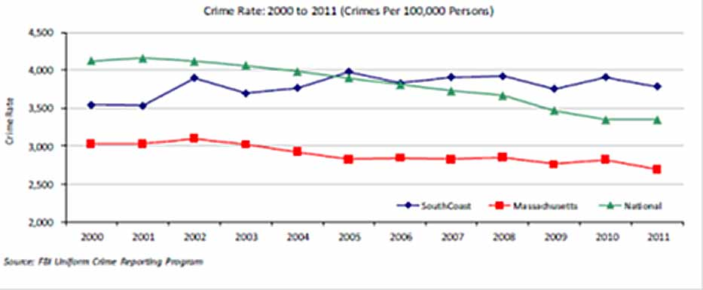

Health Factor VI: | Community Safety and Violence Prevention | Problems with crime, abuse, bullying |  | Goal: | Less PTSD, premature death
Problem Area | Strategic Goal | Strategy | Activity | Resources | Measures | Achieved
Mental health issues and trauma histories, including their impact on violence toward self and others, are of a major concern in this city | Reduce rates of psychological trauma and self-harm | Increase trauma-informed care training | Increase relationship violence training in schools and agencies | Local agencies who provide relationship training programs | Number of trainings held | Count of trainings
42:

Health Factor VI: | Community Safety and Violence Prevention | Problems with crime, abuse, bullying |  | Goal: | Less PTSD, premature death
Problem Area | Strategic Goal | Strategy | Activity | Resources | Measures | Achieved
Mental health issues and trauma histories, including their impact on violence toward self and others, are of a major concern in this city | Reduce rates of psychological trauma and self-harm | Increase trauma-informed care training | Provide training in Search Institute Developmental Assets to all adults who have contact with youth | New Bedford Responsible Attitudes toward Pregnancy, Parenting & Prevention Program | Number of trainings held | Count of trainings
43:

Health Factor VI: | Community Safety and Violence Prevention | Problems with crime, abuse, bullying |  | Goal: | Less PTSD, premature death
Problem Area | Strategic Goal | Strategy | Activity | Resources | Measures | Achieved
Mental health issues and trauma histories, including their impact on violence toward self and others, are of a major concern in this city | Reduce rates of psychological trauma and self-harm | Increase trauma-informed care training | Increase teacher and parent involvement in parent cafes and facilitated training | Children's Trust Fund and United Neighbors of Fall River | Number of parent cafes held | Count of parent cafes
44:

Health Factor VI: | Community Safety and Violence Prevention | Problems with crime, abuse, bullying |  | Goal: | Less PTSD, premature death
Problem Area | Strategic Goal | Strategy | Activity | Resources | Measures | Achieved
Mental health issues and trauma histories, including their impact on violence toward self and others, are of a major concern in this city | Reduce rates of psychological trauma and self-harm | Increase conflict resolution and social skills | Extend Peace by Piece efforts beyond a one-day event | Grant funding and support from Partners if needed | Number of Peace By Piece extended activities held | Count of activities
45:

Health Factor VI: | Community Safety and Violence Prevention | Problems with crime, abuse, bullying |  | Goal: | Less PTSD, premature death
Problem Area | Strategic Goal | Strategy | Activity | Resources | Measures | Achieved
Mental health issues and trauma histories, including their impact on violence toward self and others, are of a major concern in this city | Reduce rates of psychological trauma and self-harm | Increase conflict resolution and social skills | Hold an annual meeting with school and community personnel to develop a strategy | School -Community Partnership Task Force | Annual meeting held | Documentation of meeting held
46:

Health Factor VII: Family, Cultural and Social Support, and Housing

The region’s total population has changed little over the past 10 years and is likely to grow slowly over the next decade, although the proportion of residents age 65 years and older continues to increase modestly. The population is less diverse in the South Coast than it is statewide; 79.5% of South Coast residents are white non-Hispanic, compared to 70.8% of residents across the state.
Population growth and residential development have been uneven within the region; the total population in the cities of Fall River and New Bedford declined by 7.3% (-14,746 residents) between 1970 and 2010, while the South Coast’s suburban towns experienced population growth of 43.3% during the same period (+47,730 residents). The area’s uneven growth pattern – population declines in the cities and population increases in its suburbs - is putting pressure on the physical infrastructure, school systems, and administrative capacities of many local governments. Age cohorts in the South Coast are similar to statewide averages, although the South Coast has a slightly higher percentage of residents age 65 and older in comparison to the state. Population cohorts have remained relatively stable over the past two decades.
The population is less diverse in the South Coast than it is statewide; 79.5% of South Coast residents are White non-Hispanic, compared to 70.8% of residents across the state. Additionally, 7.3% of South Coast residents are Hispanic, 3.5% are African American, 0.5% are American Indian, 1.4% are Asian, 0.03% are Pacific Islander, 4.6% are some other race, and 3.1% are two or more races. The 2010 Greater Fall River Area is 90.6% White, 3.6% Black, 3.0% Other, 2.2% Asian and less than one percent American Indian or Hawaiian. Of these, 5.0% are Hispanic. The City of Fall River is 86.6% White, 5.2% Black, 4.3% Other, 2.9% Asian, and less than 1% American Indian and Hawaiian. Of these, 7.2% are Hispanic.
Table 2. Race and Ethnicity 2010
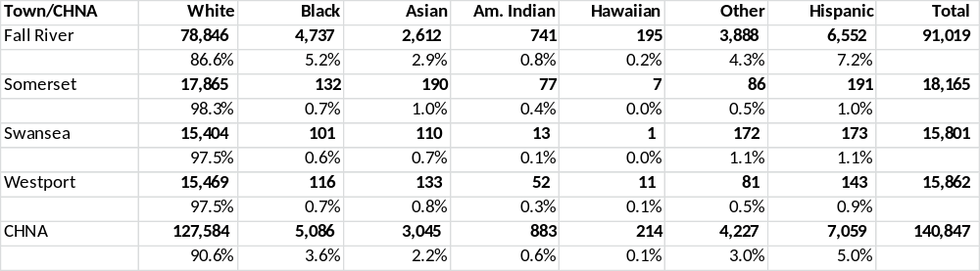
The South Coast has always been an attractive place to settle for immigrants. Over fifteen percent (15.3%) of residents in the region are foreign-born, which is just over the statewide average of 14.7%. Fall River (19.1%) has the highest percentage of foreign-born residents in the region.
Percent Foreign-Born Population
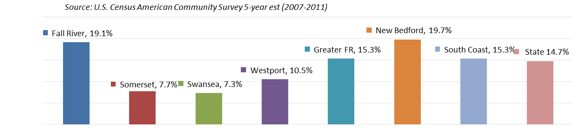
While persons with limited English proficiency reside throughout the City of Fall River, those with limited English proficiency are concentrated in three areas of Fall River: 1) the Columbia Street Neighborhood, located South of Route 195 on the western side of the City, composed primarily of Portuguese-Speakers, 2) the Flint Neighborhood, located just north of Route 195 in the center of the City, composed of Cambodian, Portuguese (including Brazilian Portuguese) and Spanish-speakers, and 3) the Sandy Beach Neighborhood, located at the far South West corner of the City, composed primarily of Azorean Portuguese-speakers.
Table 3. Language Spoken at Home (Ages 65+): Greater Fall River
 | Area  Count | Area  Percent | State  Percent
Speak Language other than English at Home | 7,759 | 32.4 | 16.5
Speak English Not Well or Not at All | 2,649 | 34.1 | 29.0
Speak Spanish at Home | 118 | 0.5 | 1.6
Speak English Not Well or Not at All | 13 | 11.0 | 48.4
MassCHIP 12/6/2010, Massachusetts Department of Public Health

Health Factor VII: | Family, Cultural and Social Support, and Housing | Problems with language, race, ethnicity, cultural values, maternal care, single parent households, homelessness |  | Goal: | Decreased racism, stress, disconnection from community resources
Problem Area | Strategic Goal | Strategy | Activity | Resources | Measures | Achieved
The number of people experiencing homelessness is continuing to rise as is the population of homeless families in local motels. | Increase the availability of resources to homeless individuals and families | Develop and maintain a listing of locally-available resources for homeless individuals and families | Create and distribute resource listing | Life Together Fellow and SCI interns at United Neighbors and United Way | Listing created and distributed | Number of listings distributed
47:

Health Factor VII: | Family, Cultural and Social Support, and Housing | Problems with language, race, ethnicity, cultural values, maternal care, single parent households, homelessness |  | Goal: | Decreased racism, stress, disconnection from community resources
Problem Area | Strategic Goal | Strategy | Activity | Resources | Measures | Achieved
The number of people experiencing homelessness is continuing to rise as is the population of homeless families in local motels. | Increase the availability of resources to homeless individuals and families | Educate landlords about housing resources | Provide information to local landlords | Life Together Fellow and SCI interns at United Neighbors and United Way | Information provided | Documentation of information provided
48:

Health Factor VII: | Family, Cultural and Social Support, and Housing | Problems with language, race, ethnicity, cultural values, maternal care, single parent households, homelessness |  | Goal: | Decreased racism, stress, disconnection from community resources
Problem Area | Strategic Goal | Strategy | Activity | Resources | Measures | Achieved
The number of people experiencing homelessness is continuing to rise as is the population of homeless families in local motels. | Increase the availability of resources to homeless individuals and families | Continue job support with SER-Jobs and Community Health Worker Training projects | Create job and job training opportunities to homeless individuals | SER-Jobs and United Interfaith Action CHW job development and training projects | Number of jobs and job training slots provided | Count of jobs and job training slots
49:

Health Factor VII: | Family, Cultural and Social Support, and Housing | Problems with language, race, ethnicity, cultural values, maternal care, single parent households, homelessness |  | Goal: | Decreased racism, stress, disconnection from community resources
Problem Area | Strategic Goal | Strategy | Activity | Resources | Measures | Achieved
The number of people experiencing homelessness is continuing to rise as is the population of homeless families in local motels. | Increase the availability of resources to homeless individuals and families | Increase transportation opportunities to families in local motels | Organize regular bus transportation to Fall River resources to families in Somerset and Swansea | People Incorporated transportation grant; Vela Foundation grant | Number of bus trips provided | Count of bus trips to Fall River
50:

Health Factor VII: | Family, Cultural and Social Support, and Housing | Problems with language, race, ethnicity, cultural values, maternal care, single parent households, homelessness |  | Goal: | Decreased racism, stress, disconnection from community resources
Problem Area | Strategic Goal | Strategy | Activity | Resources | Measures | Achieved
The number of people experiencing homelessness is continuing to rise as is the population of homeless families in local motels. | Increase the availability of resources to homeless individuals and families | Establish a food bank warehouse accessible to all Fall River food pantries | Identify suitable location and fund renovations needed | Fall River Food Pantry, Project Bread, and donated location | Food Bank warehouse opened and operational | Food bank opened
51:

Health Factor VII: | Family, Cultural and Social Support, and Housing | Problems with language, race, ethnicity, cultural values, maternal care, single parent households, homelessness |  | Goal: | Decreased racism, stress, disconnection from community resources
Problem Area | Strategic Goal | Strategy | Activity | Resources | Measures | Achieved
The number of people experiencing homelessness is continuing to rise as is the population of homeless families in local motels. | Increase the availability of resources to homeless individuals and families | Hire a full-time "food guru" at United Way to organized food resources on a 24/7 basis | Write grant application, recruit and hire person, supervise and link with existing resources | United Way of Greater Fall River with Social Capital Inc providing funding and recruiting interns | Position funded and person hired | Funding in place a person hired
52:

Health Factor VIII: Environment & Infrastructure

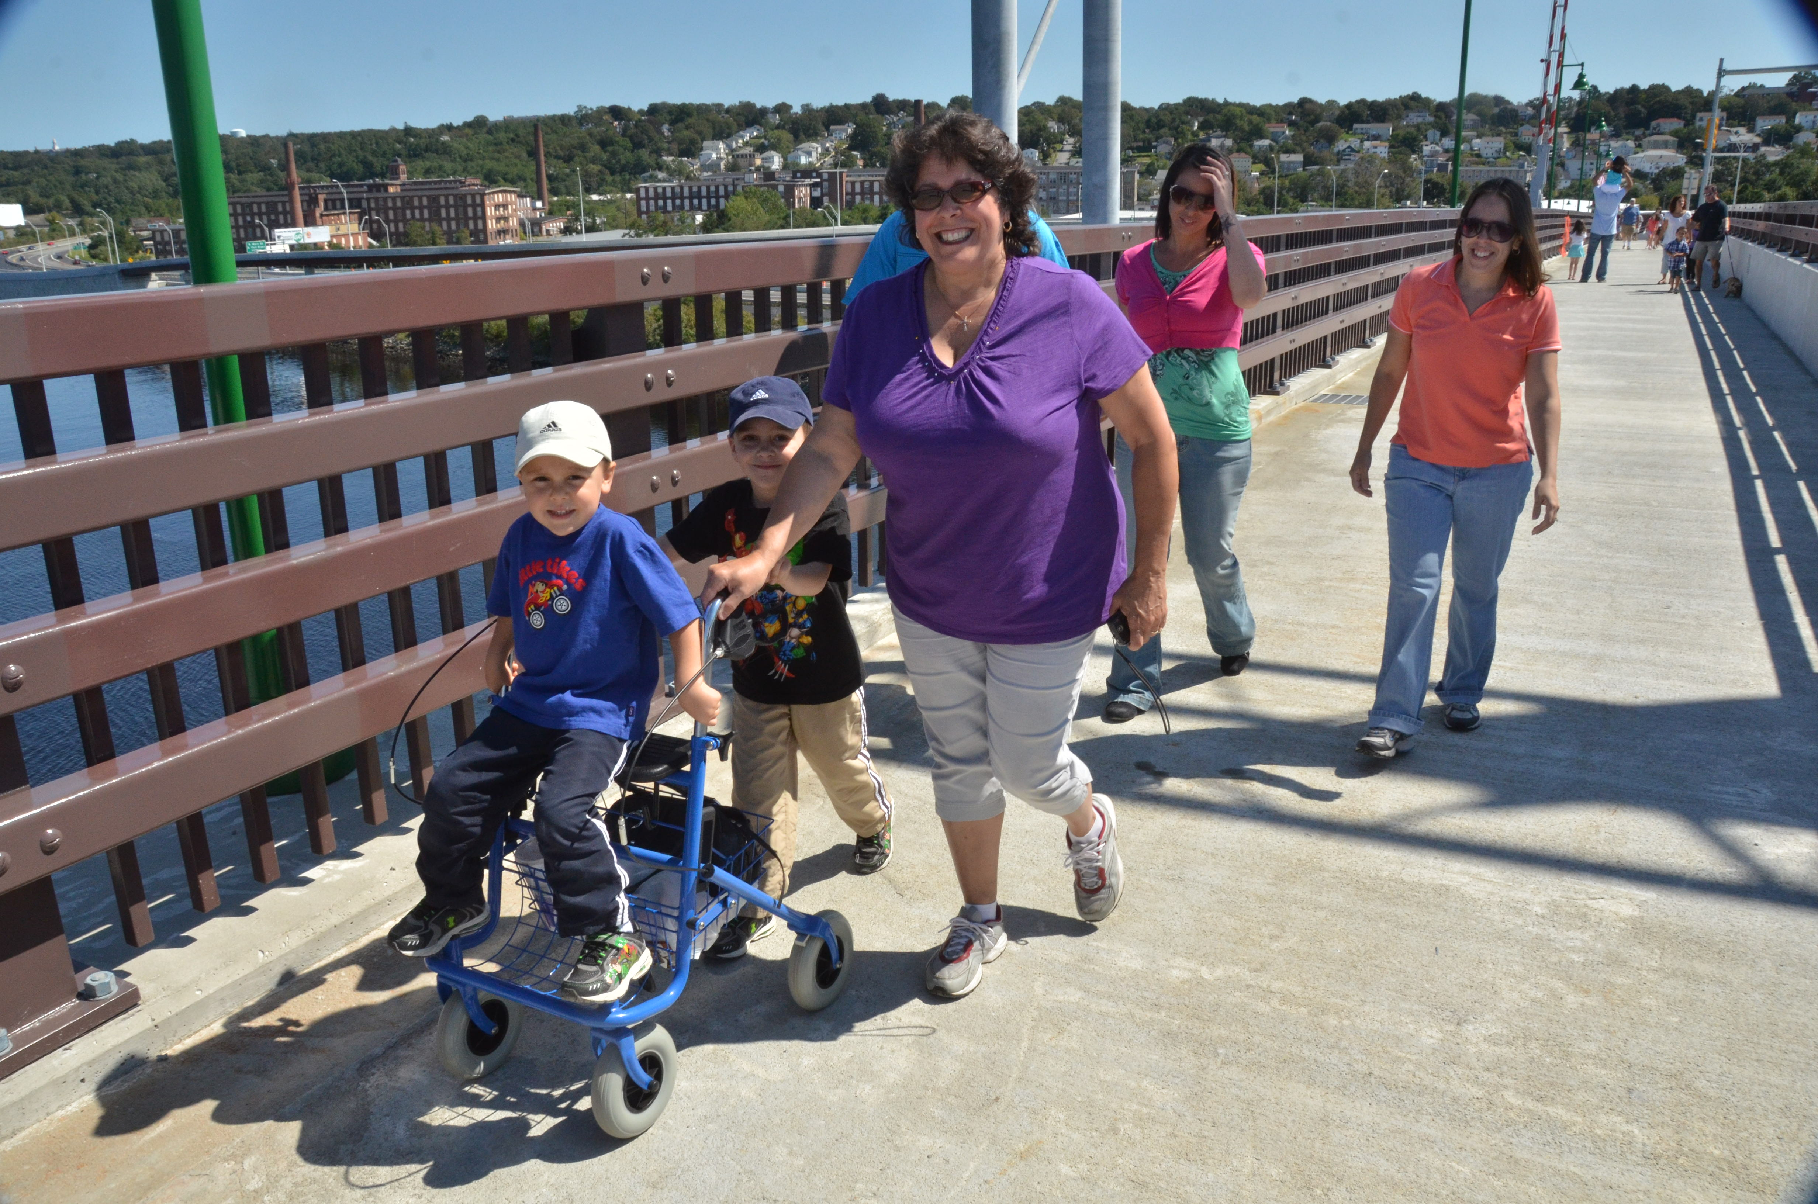
An understanding the influence of the physical environment on health status have led to efforts to revitalize the waterfront, improve streets and sidewalks and deal with some of the City’s deteriorating housing . Over seven miles of streets and sidewalks have been replaced as part of a Combined Sewer Overflow project that mandated new water lines, thus providing the opportunity to make the city more walkable. Several housing projects constructed to house returning World War II veterans have been upgraded or rebuilt, and major plans to reconstruct the City’s waterfront area and connecting highways are moving into construction. Even the City’s boardwalk along the Taunton River that attracts thousands of walkers year-round is being refurbished. Each of these projects demonstrates a commitment by the City to improve the physical structures that support a healthier lifestyle and the willingness to pursue state and federal resources needed to accomplish them.
The Open Space and Recreation Plan, rewritten in 2010, spells out a vision of walkable streets, a bicycle friendly city, and care and access to open spaces. Major new funding resources identified by the City officials and the Mass in Motion coordinator is helping to provide millions of dollars in improvements to existing parks as well as the creation of a major new bicycle and walking path through the center of one of the most neglected natural spaces in the City. A recently-completed path now connects three elementary schools, a middle school, three high schools and two community colleges. New construction on Plymouth Avenue includes bicycle lanes, thanks to the advocacy of the Mass in Motion coordinator and the newly formed Fall River Bicycle Committee, and regional planning has begun for a South Coast Bikeway linking Fall River to Wareham is well underway. A new bus station and front-mounted bike racks on the buses are helping to make the City truly multi-modal. The City’s parks are also being improved with the advocacy of volunteer Park Advocate volunteers and an Adopt-a-Park program that worked with neighborhood associations to install handicapped accessible playground equipment. Plans are underway for the creation of a walking path completely surrounding Cook Pond in the City’s South End, an area that has been neglected for much of the past century but one that offers spectacular water views and a path that can connect residents with some of the wild and natural areas of the City.

Health Factor VIII: | Environment & Infrastructure |  | Problems with non-vehicular transportation |  | Goal: | Increased physical activity and access to recreational resources
Problem Area | Strategic Goal | Strategy |  | Activity | Resources | Measures | Achieved
Improved access to public transportation and its connectivity to schools, jobs, parks, medical centers and shopping needed | Develop a Bicycle Master Plan for the City of Fall River | Map routes to key destinations (school, work, shopping, recreation) to ensure bicycle access |  | Create maps designating bicycle routes throughout the Area | Mass in Motion and Fall River Bicycle Committee | Map created and distriubted | Number of maps distributed
53:

Health Factor VIII: | Environment & Infrastructure |  | Problems with non-vehicular transportation |  | Goal: | Increased physical activity and access to recreational resources
Problem Area | Strategic Goal | Strategy |  | Activity | Resources | Measures | Achieved
Improved access to public transportation and its connectivity to schools, jobs, parks, medical centers and shopping needed | Develop a Bicycle Master Plan for the City of Fall River | Create a bicycle culture that recruits new cyclists and addresses bicycle safety in a vehicle-oriented community |  | Plan and implement a comprehensive bicycle safety program; Trips for Kids, Bike Fall River | Southeastern Regional Planning & Economic Development District, MASSBIKE, Safe Routes to School | Number of safety sessions offered, number of organized bicycle trips offered for children and adults | Count of safety sessions and bicycle trips
54:

Health Factor VIII: | Environment & Infrastructure |  | Problems with non-vehicular transportation |  | Goal: | Increased physical activity and access to recreational resources
Problem Area | Strategic Goal | Strategy |  | Activity | Resources | Measures | Achieved
Improved access to public transportation and its connectivity to schools, jobs, parks, medical centers and shopping needed | Standardize Physical Education Curriculum to include Safe Walking and Cycling | Review and revise School Wellness Plan to address safe walking and cycling |  | Standardize the PE curriculum for the FR Public Schools to include walking and cycling | Partners School Wellness Coordinator's time and Mass In Motion participation on the Wellness Committee | Inclusion of language in the Wellness Plan to address pedestrian and bicycle participation and safety | Wellness Policy language included
55:

Health Factor VIII: | Environment & Infrastructure |  | Problems with non-vehicular transportation |  | Goal: | Increased physical activity and access to recreational resources
Problem Area | Strategic Goal | Strategy |  | Activity | Resources | Measures | Achieved
Increase physical access to healthy food, especially to low-income areas and people who lack automobile transportaion | Create a Five-Minute Walk to a Healthy Market Program | Identify potential markets that agree to upgrades using the Healthy Market Toolkit |  | Expand shelf space and improve locations of healthier food options | MIM staff to locate markets based on owner interest to increase and promote healthier choices | Five markets with interest and potential to expand availability of healthier food options identified | Number of participating markets
56:

Health Factor VIII: | Environment & Infrastructure |  | Problems with non-vehicular transportation |  | Goal: | Increased physical activity and access to recreational resources
Problem Area | Strategic Goal | Strategy |  | Activity | Resources | Measures | Achieved
Increase physical access to healthy food, especially to low-income areas and people who lack automobile transportaion | Create a Five-Minute Walk to a Healthy Market Program | Create map of the 1/2 mile radius of all markets offering healthy food options |  | Locations plotted and analyzed; healthy market locations plotted; map produced and publicized | MIM staff; Cancer prevention project staff; Healthy City Coordinator | Map created and distributed | Number of maps distributed
57:

Health Factor VIII: | Environment & Infrastructure |  | Problems with non-vehicular transportation |  | Goal: | Increased physical activity and access to recreational resources
Problem Area | Strategic Goal | Strategy |  | Activity | Resources | Measures | Achieved
Increase physical access to healthy food, especially to low-income areas and people who lack automobile transportaion | Create a Five-Minute Walk to a Healthy Market Program | Brand a Five-Minute Walk to a Healthy Market program and advertise using English and non-English messages |  | Five-minute walk program created in multiple languages and widely publicized | MIM staff; Cancer prevention project staff; Healthy City Coordinator | Branding project completed | Branding advertisement count
58:

Health Factor VIII: | Environment & Infrastructure |  | Problems with non-vehicular transportation |  | Goal: | Increased physical activity and access to recreational resources
Problem Area | Strategic Goal | Strategy |  | Activity | Resources | Measures | Achieved
Improve and increase resources and awareness of active living resources | Improve and expand parks and open spaces and awareness of and access to both | Search and identify funding sources for park and open space improvements; complete planning and apply for funding |  | Grant opportunity search; coordination with Mayor's Office and Grantwriter | City grant writer; Parks and Recreation Department; Department of Community Maintenance | Grants identified and secured; projects underway and completed | Number of grants; number of improved and expanded parks and open spaces
59:

BRFSS 2011, via MassCHIP
Instant topics - Adolescent Health Report, 2009.
http://www.healthypeople.gov/2020/LHI/oralHealth.aspx
BRFSS 2008.
CHNA data not available; BRFSS 2006-10 via Community Commons.

