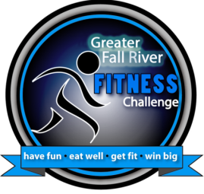
Greater Fall River Fitness Challenge

Participant Application

Please print neatly

First Name: |  |  |  |  |  |  |  |  | Last Name:
Address:
City: |  |  |  |  |  |  | State: |  |  |  |  |  |  |  |  |  | Zip Code:
Email Address: |  |  |  |  |  |  |  |  |  |  |  |  |  | Contact Phone:
I am participating as an individual: |  | ❒ | Yes | ❒ |  | No
I am part of a team: |  | ❒ | Yes | ❒ |  | No |  |  |  | Team Name:
I am a Team Captain: |  | ❒ | Yes | ❒ |  | No |  |  |  | Captain Name:
How many years have you participated in the Fitness Challenge?

Age: | ❒ | 16-19 | ❒ | 20-29 | ❒ | 30-39 | ❒ | 40-49 | ❒ | 50 and over
Gender: | ❒ | Female | ❒ | Male

Informed Consent for Program Participation

I, _________________________________, do hereby apply application and give release to the Greater Fall River RE-CREATION, Greater Fall River Partners for a Healthier Community and all participating sponsors and partners, its staff and instructors, to be accepted and permitted to participate in the Greater Fall River Fitness Challenge programs. In consideration of being accepted into this program, I do, on behalf on myself, my heirs, executors and administrators, release and discharge the said programs and all its agents and employees from any claims of demands which I now have or any time in the future may have resulting from any illness, injury or occurrence as a result of participation in this program.
Furthermore, I agree to look to my private physician for medical care and certify that I am in good physical health and I am able to undertake and engage in the range of physical activities in which I choose to participate. I also agree to allow for pictures and/or videos of me to use for further promotion of this program.
Signature: |  | Date:

For Office Use Only:
Key tag ID: | ___________________ |  | Starting Weight: | ___________________

