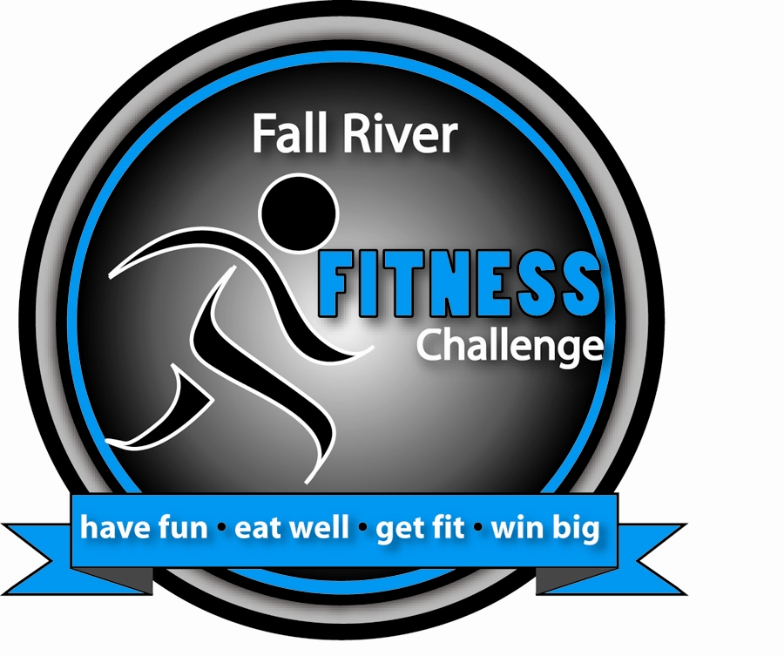
Fall River Fitness Challenge
Have fun, eat well, get fit, and win big!

Name: __________________________________________________

Primary Email Address: ____________________________________

Home address: ___________________________________________

_______________________________________________________

Contact Phone: __________________________________

I am participating as an individual: (Yes / No)

I am part of a team: (Yes / No) I am a Team Captain: (Yes / No)
Team Name: ____________________________

Age: __________ Gender: ________

Informed Consent for Program Participation

I, _____________________________________________, do hereby make application and give release to the Diabetes Association Inc., (DAI), CD REC, YMCA and Healthy City Fall River, its staff and instructors, to be accepted and permitted to participate in the Fall River Fitness Challenge programs. In consideration of being accepted into this program, I do, on behalf of myself, my heirs, executors and administrators, release and discharge the said programs and all its agents and employee from any claims of demands which I now have or any time in the future may have resulting from any illness, injury or occurrence as a result of participation in the program. Furthermore, I agree to look to my private physician for medical care and certify that I am in good physical health and am able to undertake and engage in the range of physical activities in which I chose to participate. I also agree to allow for a pictures and/or videos of me to use for further promotion of the program.

Signature: __________________________________Date: __________

STARTING WEIGHT: _____________

