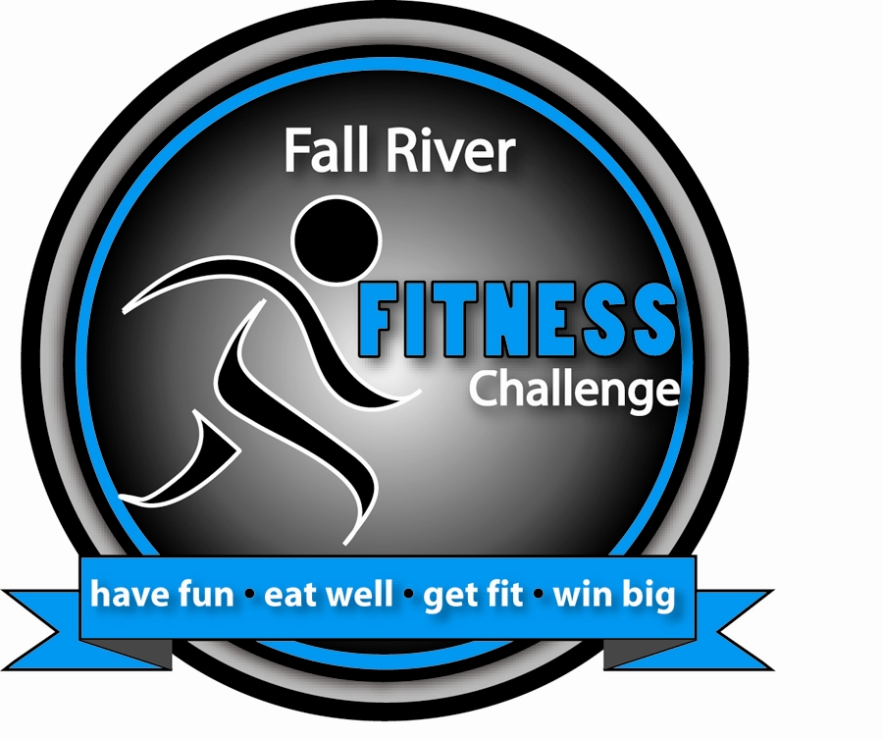
Fall River Fitness Challenge 2012 Registration Form
Have fun, eat well, get fit, and win big!

Name: _________________________________________________________________

Primary E-mail Address: __________________________________________________

Home address: ___________________________________________________________

(Home Zip Code) _________(Work Zip Code) _________ (School Zip Code) ________

____ I understand that I will receive program information from time to time via e-mail.
____ I permit the Fitness Challenge to share my e-mail address with Challenge sponsors
____ I certify that I live, work, or attend school in Fall River, Somerset, Swansea, or Westport

Contact Phone: _________________ This is a ____ home, ____ work, ____ cell number

I am participating as an individual: (Yes / No) OR

I am part of a team: (Yes / No) Team Captain: _____________________________

Team Name & Organization: ______________________________________________

Age: __ Gender: __ M __ F I participated in the __ '08, _ '09, __ '10 __ '11 Challenge

Informed Consent for Fitness Challenge Program Participation

I, (print name) _____________________________________________, do hereby make application and give release to Community Development Recreation, General Fitness, Partners for a Healthier Community, Inc., and the Southcoast YMCA, their staff and instructors, to be accepted and permitted to participate in any Fall River Fitness Challenge programs or related activities. In consideration of being accepted into this program, I do, on behalf of myself, my heirs, executors and administrators, release and discharge the said programs and all its agents and employee from any claims of demands which I now have or any time in the future may have resulting from any illness, injury or occurrence as a result of participation in the program. Furthermore, I agree to consult my private physician for medical care and to certify that I am in good physical health and am able to undertake and engage in the range of physical activities in which I chose to participate. I also agree to allow pictures and/or videos to be taken of me during any Fitness Challenge activity for promotion of the program.

Signature: ________________________________________________Date: __________

Please return this to your team MY HEIGHT IN INCHES: ____________
captain or to CD-Rec, 72 Bank St. STARTING WEIGHT: _______________

