Flaxseed Meal-Peanut Butter Hot Cereal
I am not a cereal person per say. I never liked cold cereals as a kid -- although I would eat anything granola-like. Oatmeal has always been a favorite but I am not talking the packets of instant, flavored stuff -- just good, old fashioned oats, or even better steel-cut oats. They are great for those of you who can tolerate carbs, I cannot so no more oatmeal for me. Recently, I was turned on to this recipe that is credited to Laura Dolson.
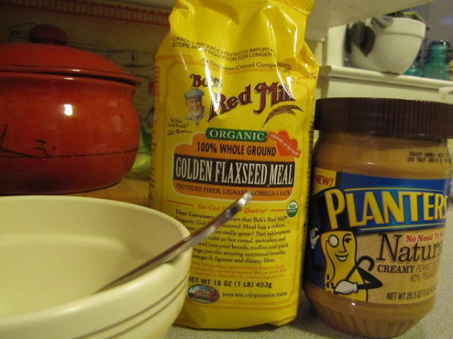
1/4 cup flaxseed meal
1/2 cup boiling water
2 Tbsp peanut butter
1/4 tsp cinnamon
Pour boiling water over flaxseed meal and stir well. Stir in peanut butter and cinnamon. Let thicken for 1-2 minutes. Eat. Makes 1 serving.
.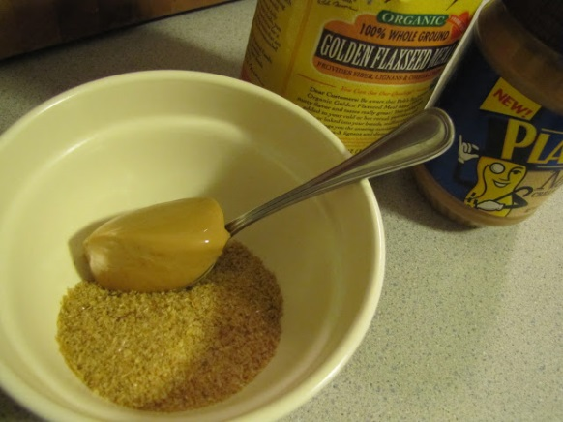
This cereal is very high in fiber and oh, so delicious. The nutrition info will be determined by what type of peanut butter you use. I use Planter's Natural and my calories for the cereal is 312 with only 3.16 net carbs. I find this is so satisfying that I am surprised to find it after lunchtime and no hunger at all. I had this last weekend before my 10k.
Source: http://faithfulnessfarm.blogspot.com/2012/09/low-carb-living-breakfasts-of-champions.html

