
Regional Conference on Sustainability: Building A Sustainable SouthCoast
April 27th 8:30am-4:30pm
Agenda
8:30 Welcome with Morning Refreshments
Sarah Garrett, Vice President Academic Affairs - Bristol Community College
Building Sustainable Communities (9:00am-12:00pm)
9:00 Keynote Address - Mark Sylvia
Director of the Green Communities Division of the Department of Energy Resources

Coffee Break (10:00 am)
10:15 Panel Discussions
Energy Moderator Susan Peterson
Nelson Medeiros - Lead Program Manager, NSTAR Electric
Helen Sahi - Manager/Sr. Consultant, Green Practices, Energy New England
Scott Durkee - Energy Manager, City of New Bedford
Greening Your Community Moderator Ross Perry
Deirdre Healy, Fairhaven Sustainability Committee
Steve Smith, Executive Director, Southeastern Regional Planning and Economic Development District(SRPEDD)
Bill Fitzgerald, Superintendent, Board of Public Works-Town of Fairhaven
Lunch Break (12:00)
12:30 Richard Heinberg
Nancy Lee Wood, Director Institute for Sustainability-Bristol Community College

Coffee Break (1:40pm)

Building Sustainable Businesses (2:00pm-4:30pm)

2:00 Green Business Panel-Moderator Susan Jennings
Glenn Bachman, President, Raven Business Group LLC, CMC,
Robert Thomas, Vice President, Product Dev. & Engineering Lite Control

3:00 Buy Local Panel
Dick Shafer, Economic Development Director, City of Taunton Office of Economic and Community Development
Robert Mellion, President and CEO of the Fall River Area Chamber of Commerce
Sarah Cogswell, Buy Local Coordinator, Southeastern Massachusetts Agricultural Partnership
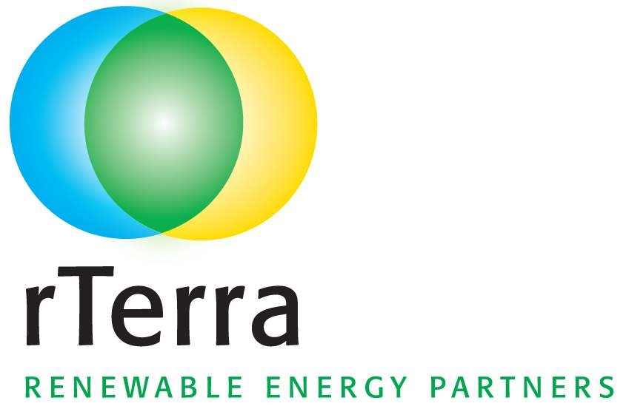
4:30 Networking
Wine and Cheese provided by Westport Winery

Sponsored by:

