Healthy City Fall River
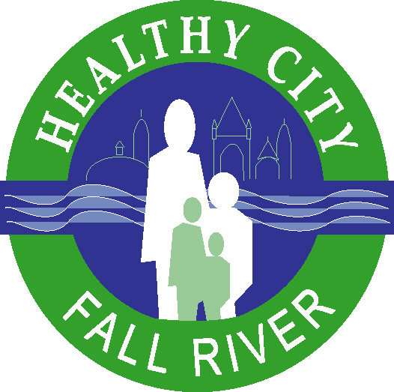
One Government Center, Room 422
Fall River, MA 02722
508-324-2411
www.HealthyCityFallRiver.org

Soda Free Summer Invitation

Healthy City Fall River has launched a Soda-Free Summer Pledge invitation to children of all ages in the City.

Why?

- Americans are swallowing 22 teaspoons of sugar each day, and it's time to cut way back, the American Heart Association says.

- Most of that added sugar comes from soft drinks and candy — a whopping 355 calories, the equivalent of guzzling two cans of soda and eating a chocolate bar every day!

- In 2009, 28.6% of Fall River adults were considered obese and 57.8% in Southeastern Massachusetts were considered overweight in 2005.

- In 2009, 31.9% of Fall River school students were either overweight or obese.

The calories from drinking one 12-ounce can of sugar sweetened beverage per day (150 kcal) can result in gaining 15 extra pounds per year, or 25 extra pounds for a 20-ounce bottle of soda.

- An average adult would have to walk 25 minutes at a moderate pace to burn off the calories in a 12 ounce soda.

- A 75 pound child would need to bicycle vigorously for 30 minutes to burn off the calories in a 12 ounce soda.

- Soda, juice, and sports drinks can also cause dental cavities.

Instead of soda and other sugary drinks, what should children be drinking?

- Water--all you want, preferably from the tap or a bubbler
- You can use a splash of 100% fruit juice or pieces of real fruit to create your own flavored waters
- Sodium-free seltzer, as much as you want
- Milk, preferably low fat and non-flavored types

Steer clear of drinks with added sugar such as:

- Fruitades (lemonade, etc.)
- Juice drinks/ juice cocktails
- Fruit punches
- Sweetened iced teas
- Vitamin waters

Sugar in drinks may be labeled as:

- Fruit juice concentrate
- Evaporated cane juice
- Malt syrup
- Sucrose
- Dextrose
- Fructose
- High fructose corn syrup
- Corn sweetener

What about sports drinks?

Sports drinks are only helpful for highly intense activities that last longer than one hour. For example, a day at basketball camp or a long hike would be a time that kids might have a sports drink.

Is bottled water a healthier choice than tap water?

Not necessarily. Just because water comes out of a bottle, there is no assurance that it is any cleaner or safer than water from the tap. Bottled water is not as rigorously regulated as tap water and, unlike water from the tap, often lacks fluoride, which is essential for dental health. Water that comes from your tap costs a lot less than bottled water. If you need to carry water, fill your own bottle at the tap and chill it in the refrigerator.

How does juice compare to soda?

100% fruit juices have about as many calories as sodas and other sweetened soft drinks, but they also contain vitamins and minerals. It is best to limit the intake of fruit juice to four ounces a day and instead eat more whole fruits rich in fiber and other nutrients.

Is diet soda better than regular soda?

Diet soda does not contain the sugar and calories that regular soda does, but it is still not considered a healthy drink choice. By drinking diet or regular sodas, you are replacing a healthy drink option with one that provides no nutritive value. Colas and diet colas also contains phosphoric acid, an ingredient that could increase a woman’s risk of bone loss later in life. For youth, the additional caffeine in many sodas can contribute to negative behavior and sleep disturbance.

Additional information is available at:

http://childrenshospitalblog.org/boston-launches-soda-free-summer-challenge/

