Southcoast Worksite
Health & Wellness
Collaborative

The majority of adults spend most of their waking hours at work, and the workplace can make it easier for employees to change their behaviors by creating a culture of health.
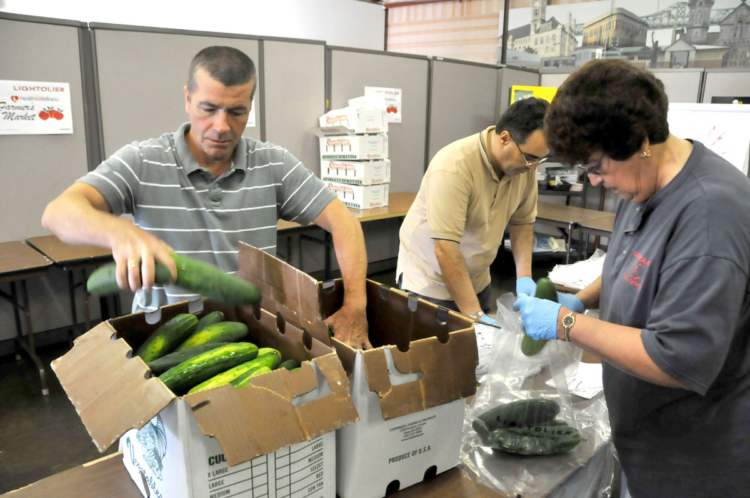
Active living, healthy eating, managing stress, and avoiding tobacco are some of the essential elements in lowering the risk for and costs of chronic disease.
The Massachusetts Department of Public Health (MDPH), Division of Health Promotion and Disease Prevention, has begun to partner with organizations and businesses in the Southcoast who have a vested interest in finding ways to improve employee health.
The Southcoast Worksite Health & Wellness Collaborative can help your organization improve morale, increase productivity, and reduce absenteeism and workers' compensation and healthcare costs.
Our Mission Statement
We are an employer-based collaborative which, in a creative and cost-effective manner, will improve the health and productivity of those who work and live in the Southcoast region.
Collaborative Goals
- To cultivate a culture of health and wellness supported by policy and environmental changes
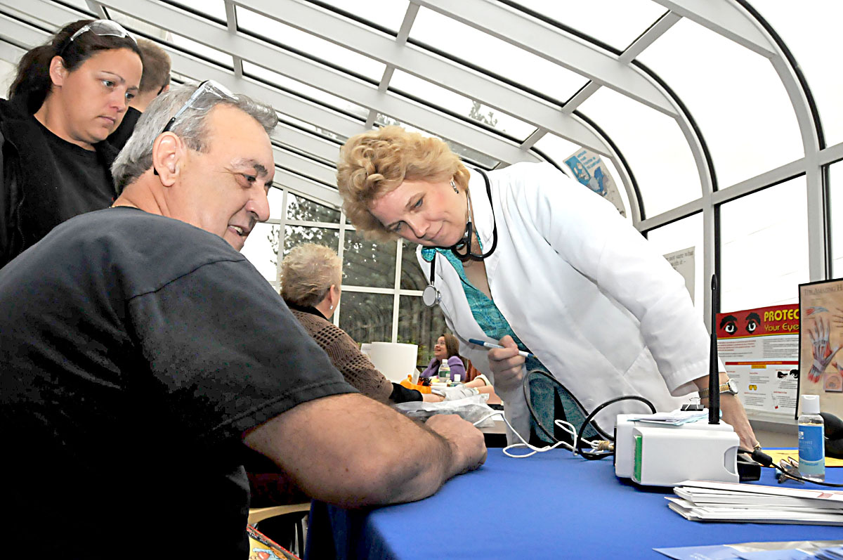
- To identify cost-effective resources for worksites of all sizes
- To create an infrastructure to support the on-going work of the collaborative
Who should participate?
- CEOs, Company Presidents, COOs, and Small Business Owners,

- Human Resource Managers and Benefit Coordinators
- Senior Managers, Union Leaders, Municipal Department Heads and Safety Officers
- Occupational Health Nurses, Wellness Coordinators, and Wellness Champions

What are the benefits of membership?

- Networking with others providing worksite health programs
- Contact listing of participating members
- Discount for attendance of Collaborative-sponsored conferences

Membership in the Collaborative

Since April 20, 2008, the Massachusetts Department of Public Health has been meeting with a group of about twenty representatives from local corporations, hospitals, agencies, chambers of commerce and colleges at the Charlton College of Business at the U-Mass-Dartmouth campus to look at how employee health could be improved through collective action.

Annual dues for membership in the Collaborative is $50 . This fee is waived with attendance of 50% of collaborative meetings.

Members are eligible for a 20% discount at all conferences sponsored by the Collaborative.

To join, complete the attached form and return with a check made payable to "Southcoast Worksite Health Collaborative"

Contact:
We welcome additional participants. Please contact us if you wish to attend our next meeting. Contact Julie Jennings (jjennings@sylviainsurance.com) at 508-995-4553 for information about our next meeting.
-----------------------------------------------------------------------------------------------------------

www.SouthcoastWorksiteHealth.com
Southcoast
Worksite
Health & Wellness
Collaborative

www.SouthcoastWorksiteHealth.com

Membership Application Form

Name ______________________________________

Organization ________________________________

Address ____________________________________

___________________________________________

Telephone __________________________________

E-Mail _____________________________________

Website ____________________________________

Check one:

___ $50 membership dues enclosed

___ Please invoice us

___ I will attend meetings (dues waived)

Please mail this form to:

Ms. Janet Hathaway
Southcoast Worksite Health & Wellness Collaborative
363 Highland Avenue
Fall River, MA 02720

Southcoast
Worksite
Health & Wellness
Collaborative

www.SouthcoastWorksiteHealth.com

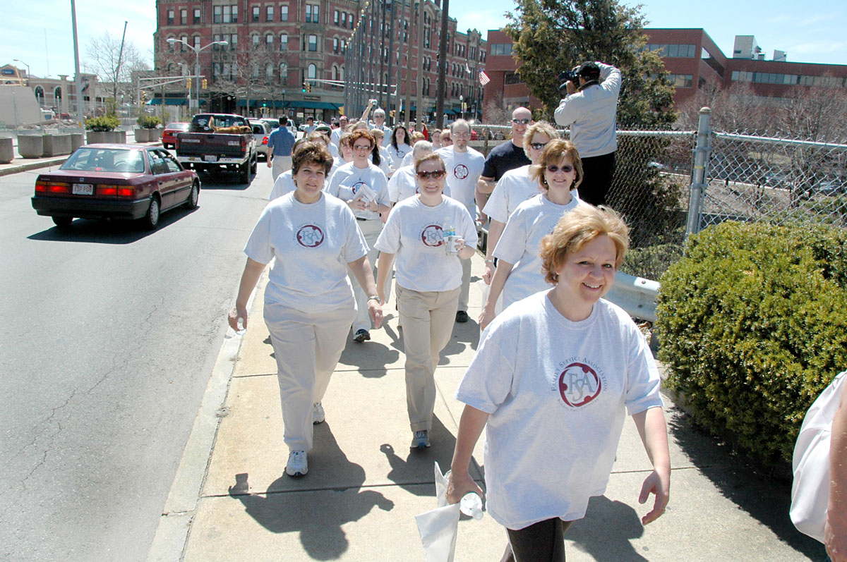

Participating Members

Acushnet Company
Aerovox Company
Bristol Community College
Citizen-Union Savings Bank
Diabetes Association
Fall River Chamber of Commerce
Family Service Association
Healthy City Fall River
Joseph Abboud Manufacturing
Julias Koch USA
Lightolier/Philips
Mass. Dept. of Public Health
New Bedford Chamber of Commerce
People Incorporated
Saint Anne's Hospital
Southcoast Hospitals
Sylvia Group Insurance
Taco, Inc.
UMass Dartmouth

