
Black Bean Taco Lettuce Wraps with Mango Avocado Salsa

Yields: 6 tacos
Ingredients
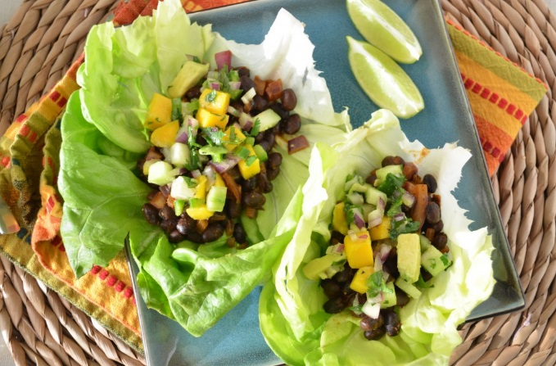
Mango Avocado Salsa:
1 mango, washed, peeled and diced
1 avocado, washed, peeled and diced
1 Tbsp fresh lime juice
½ Tbsp chopped cilantro leaves
Dash salt and pepper to tast
Taco Seasoning:
1/2 Tbsp chili powder
1/2 tsp paprika
1/2 tsp cumin
1/4 tsp oregano
1/4 tsp kosher salt
1/4 tsp ground black pepper
1/8 tsp cayenne pepper

Tacos Filling:
1 tsp coconut oil or olive oil
1 clove garlic, minced
1/2 sweet onion, finely diced
1- 14 oz can black beans, drained and rinsed
2 cups brown rice, cooked
½ cup water
6 leaves green leaf lettuce leaves, washed, pat dry

Instructions
- First prepare the salsa.
- Combine all ingredients in a bowl and mix well.
- Add salt and pepper to taste.
- Set aside.
- In a small bowl, combine all taco seasoning ingredients.
- Add coconut to a large pan over low/medium heat.
- Add garlic and onion; sauté until soft, 4-5 minutes.
- Add black beans, rice, taco seasoning and water; stir to coat.
- Sauté, stirring occasionally, until beans are heated through and water has evaporated, 2-3 minutes.
- Serve with lettuce leaves to be used as taco shells and mango avocado salsa.
- Enjoy!

